*PYTHON OUTPUTS*

**CUSTOMER**

**1.LOGIN AND REGISTRATION**

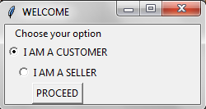

**1.1EXISTING USER-LOGIN**

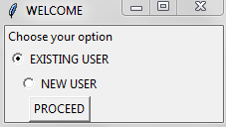

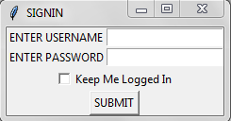

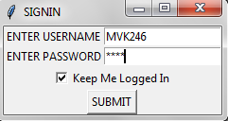

**1.1.1PASSWORD AND USERNAME NOT MATCHED**

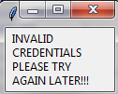

**1.1.2PASS WORD AND USERNAME MATCHED**

HAI Mathew V.Kariath WELCOME TO MEDPLUS.COM

LET'S BEGIN SHOPPING!!!,TO CONTINUE SHOPPING PRESS THE ENTER KEY:

**1.2 NEW CUSTOMER REGISTRATION**

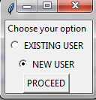

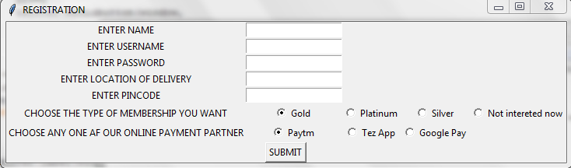

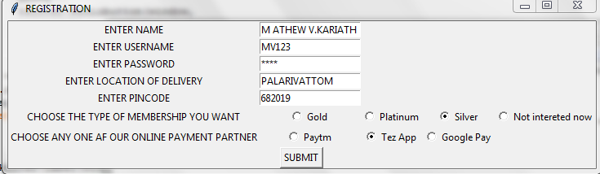

HAI MATHEW V.KARIATH WELCOME TO MEDPLUS.COM

LET'S BEGIN SHOPPING!!!,TO CONTINUE SHOPPING PRESS THE ENTER KEY:

**2.SHOPPING**

**2.1HAVE A PRESCRIPTION**

NOTE:THE USER WILL NOT HAVE THE LIST OF MEDICINES AVAILABLE IN OUR MEDICINE DIRECTORY.THE USER WILL HAVE TO ENTER THE NAMES OF THE MEDICINES AS PRESCRIBED BY THE MEDICAL PRACTITIONER

1.HAVE A PRESCRIPTION

2.NO PRESRIPTION

ENTER YOUR CHOICE: 1

ENTER NUMBER OF MEDICINES: 5

ENTER THE NAME OF THE MEDICINE: Paracetamol

ENTER THE QUANTITY REQUIRED: 12

ENTER THE NAME OF THE MEDICINE: Acyclovir

ENTER THE QUANTITY REQUIRED: 23

ENTER THE NAME OF THE MEDICINE: Paracip

ENTER THE QUANTITY REQUIRED: 90

ENTER THE NAME OF THE MEDICINE: Nicardia Retard

ENTER THE QUANTITY REQUIRED: 20

ENTER THE NAME OF THE MEDICINE: Strepsils

ENTER THE QUANTITY REQUIRED: 10

OOPS!!!NOT FOUND

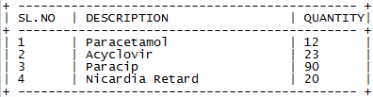

.

**2.2 HAVE NO PRESCRIPTION**

NOTE:THE USER CAN CHOOSE THE REQUIRED MEDICINEDS FROM THE LIST OF MEDICINES SEGREGATED BY THEIR TYPE.

ENTER YOUR CHOICE: 2

+ --------------------------- +

| A. | Alopathy |

+ --------------------------- +

| 1 . | Amifostine |

| 2 . | Captropil |

| 3 . | Nicardia Retard |

| 4 . | Paracip |

| 5 . | Vicks Gel |

+ --------------------------- +

+ --------------------------- +

| B. | Ayurvedic |

+ --------------------------- +

| 1 . | Acyclovir |

| 2 . | B Positive |

| 3 . | Cyclopam |

| 4 . | Paracetamol |

| 5 . | Prazoprez XL |

| 6 . | Volini |

+ --------------------------- +

+ --------------------------- +

| C. | Beauty |

+ --------------------------- +

| 1 . | Clopilet 1000mg |

| 2 . | Nutrichoice |

+ --------------------------- +

+ --------------------------- +

| D. | Health Suppliment |

+ --------------------------- +

| 1 . | Alegra |

| 2 . | Amruthanjan Roll On |

| 3 . | Busulfan |

| 4 . | Clopilet 500mg |

| 5 . | Dettol |

| 6 . | T-Bact |

+ --------------------------- +

ENTER THE NUMBER OF MEDICINES YOU WOULD LIKE TO CHOOSE: 4

ENTER THE TYPE OF MEDICINE A/B/C/D: B

ENTER THE SERIAL NUMBER OF MEDICINE: 4

ENTER THE QUANTITY YOU WOULD LIKE TO PURCHASE: 12

ENTER THE TYPE OF MEDICINE A/B/C/D: B

ENTER THE SERIAL NUMBER OF MEDICINE: 1

ENTER THE QUANTITY YOU WOULD LIKE TO PURCHASE: 23

ENTER THE TYPE OF MEDICINE A/B/C/D: A

ENTER THE SERIAL NUMBER OF MEDICINE: 4

ENTER THE QUANTITY YOU WOULD LIKE TO PURCHASE: 90

ENTER THE TYPE OF MEDICINE A/B/C/D: A

ENTER THE SERIAL NUMBER OF MEDICINE: 3

ENTER THE QUANTITY YOU WOULD LIKE TO PURCHASE: 20

**3.VIEWING THE CART AND MAKE CHANGES IF NECESSARY**



**3.1 REMOVING AN ITEM**



1.PROCEED TO PAYMENT

2.EDIT MY CART

ENTER YOUR CHOICE: 2

PLEASE ENTER THE SERIAL NUMBER OF THE ITEM YOU WANT TO MAKE CHANGE TO: 1

1.REMOVE THIS ITEM FROM THE LIST

2.MAKE A CHANGE IN THE QUANTITY

ENTER YOUR CHOICE: 1

THE ITEM HAS BEEN REMOVED FROM YOUR CART

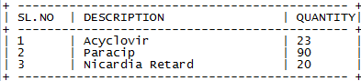

TO PROCEED TO PAYMENT PRESS THE ENTER KEY:

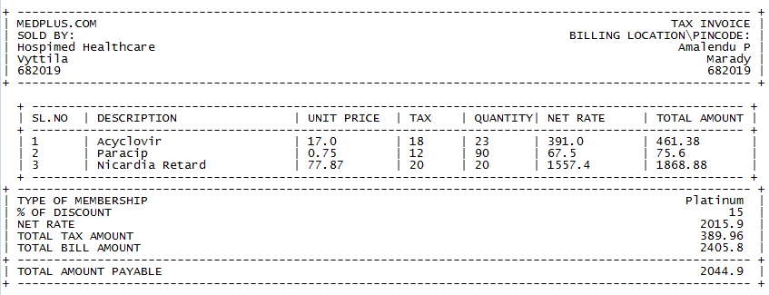

NOW IT'S TIME FOR PAYMENT!!!!

a.CASH ON DELIVERY

b.PAYMENT THROUGH OUR ONLINE PARTNER's APP

c.NET BANKING

**3.2 MAKE A CHANGE IN THE QUANTITY**



1.PROCEED TO PAYMENT

2.EDIT MY CART

ENTER YOUR CHOICE: 2

PLEASE ENTER THE SERIAL NUMBER OF THE ITEM YOU WANT TO MAKE CHANGE TO: 1

1.REMOVE THIS ITEM FROM THE LIST

2.MAKE A CHANGE IN THE QUANTITY

ENTER YOUR CHOICE: 2

PLEASE ENTER THE SERIAL NUMBER OF THE ITEM YOU WANT TO MAKE CHANGE TO: 2

1.REMOVE THIS ITEM FROM THE LIST

2.MAKE A CHANGE IN THE QUANTITY

ENTER YOUR CHOICE: 2

PLEASE ENTER THE NEW QUANTITY: 45

THE QUANTITY HAS BEEN CHANGED

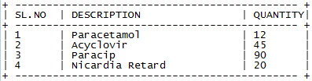

TO PROCEED TO PAYMENT PRESS THE ENTER KEY:

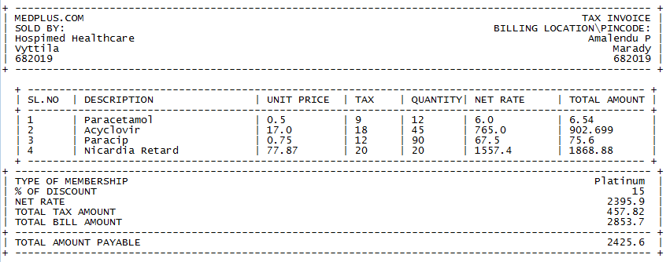

**4.PAYMENT PAGE**

1.PROCEED TO PAYMENT

2.EDIT MY CART

ENTER YOUR CHOICE: 1

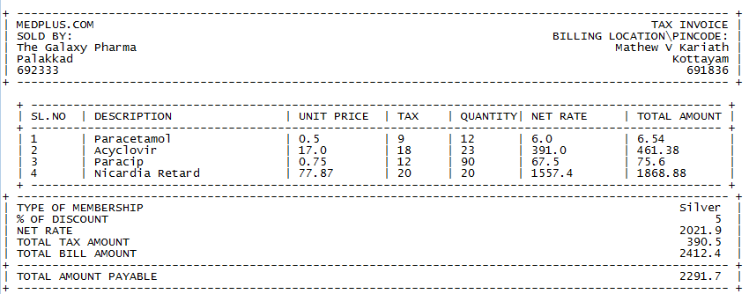NOW IT'S TIME FOR PAYMENT!!!!

a.CASH ON DELIVERY

b.PAYMENT THROUGH OUR ONLINE PARTNER's APP

c.NET BANKING

**MODE OF PAYMENT**

NOW IT'S TIME FOR PAYMENT!!!!

a.CASH ON DELIVERY

b.PAYMENT THROUGH OUR ONLINE PARTNER's APP

c.NET BANKING

ENTER YOUR CHOICE TO PROCEED:

**4.1 CASH ON DELIVERY**

ENTER YOUR CHOICE TO PROCEED: a

THANK YOU FOR CHOOSING CASH ON DELIVERY OPTION

PLEASE HAND OVER THE EXACT CHANGE TO OUR SERVICE EXCECUTIVE

THANK YOU

**4.2 PAYMENT THROUGH OUR ONLINE PARTNER's APP**

**4.2.1 CONTINUE WITH OPTION CHOSEN AT TIME OF REGISTRATION**

ENTER YOUR CHOICE TO PROCEED: b

AS PER THE DETAILS GIVEN AT THE TIME OF REGISTRATION YOU HAVE OPTED FOR Google Pay

TO CONTINUES WITH THIS PLEASE PRESS THE ENTER KEY,ELSE ENTER ANY OTHER KEY

THANK YOU FOR CHOOSING Google Pay

OUR SERVICE EXCECUTIVE WILL HELP YOU TO COMPLETE THE TRANSACTION AT THE TIME OF DELIVERY

**4.2.2CHANGE THE OPTION:**

ENTER YOUR CHOICE TO PROCEED: B

AS PER THE DETAILS GIVEN AT THE TIME OF REGISTRATION YOU HAVE OPTED FOR Google Pay

TO CONTINUES WITH THIS PLEASE PRESS THE ENTER KEY,ELSE ENTER ANY OTHER KEY no

NOW YOU CAN CHOOSE OUR PREFERRED PARTNER.THIS IS ONLY A TEMPORARY CHANGE.

1.Google Pay

2.Tez App

3.Paytm

ENTER YOUR CHOICE: 2

THANK YOU FOR CHOOSING Tez App

OUR SERVICE EXCECUTIVE WILL HELP YOU TO COMPLETE THE TRANSACTION AT THE TIME OF DELIVERY

**QR CODE GENERATION**

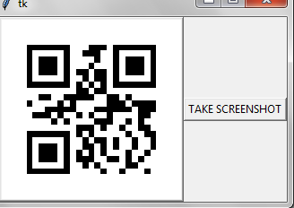

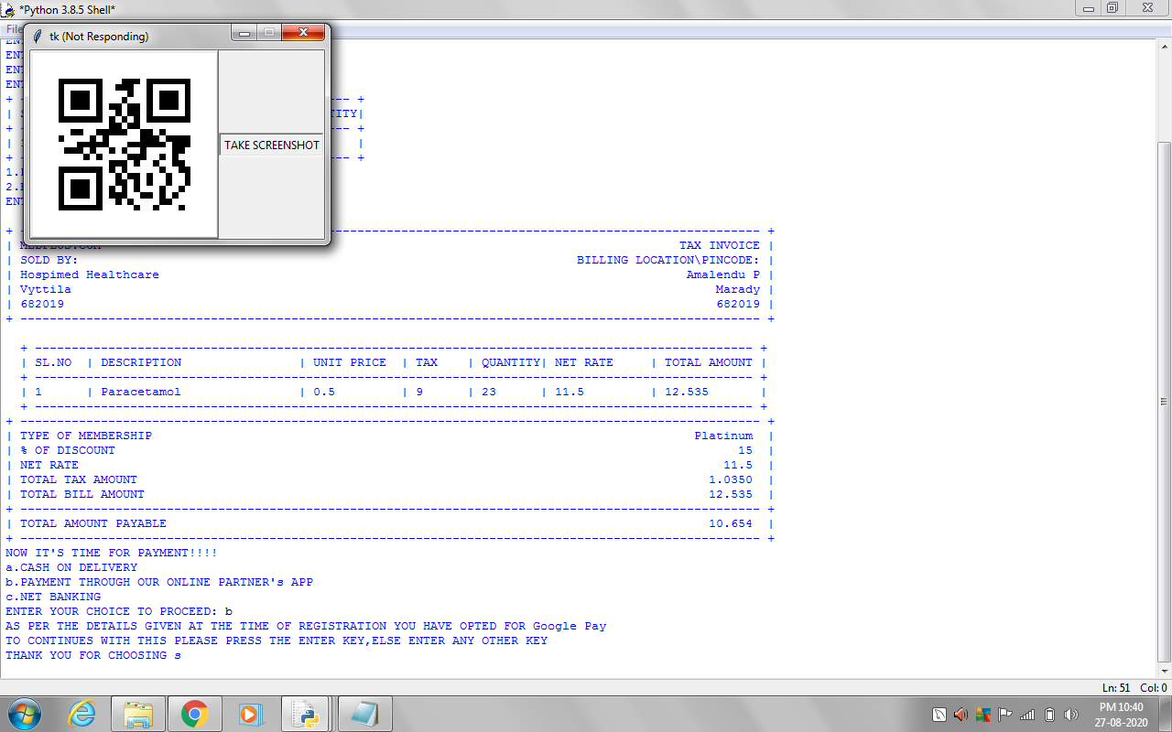 **THE SCREENSHOT TAKEN BY CLICKING “TAKE SCREENSHOT”**

**4.3 ONLINE PAYMENT**

**4.3.1EXISTING USER**:

**4.3.1.1 NO MATCH AND REGISTER NEW CARD:**

ENTER USERNAME: VMK3119

ENTER A CARD NUMBER: 6048631042374130

ENTER CVV OF YOUR CARD: 290

ENTER YEAR OF EXPIRY: 2023

ENTER MONTH OF EXPIRY: 7

INVALID CREDENTIALS

OOPS WE WERE UNABLE TO FIND THE CARD IN OUR DATABASE.

TO REGISTER A NEW CARD PRESS THE ENTER KEY:

ENTER YOUR NEW USERNAME:MVK246

ENTER YOUR CARD NUMBER: 6048631042374135

ENTER CVV NUMBER: 142

ENTER YEAR OF EXPIRY: 2023

ENTER MONTH OF EXPIRY: 09

**4.3.1.2 MATCHED**

ENTER YOUR USERNAME:MVK246

ENTER YOUR CARD NUMBER: 6048631042374135

ENTER CVV NUMBER: 142

ENTER YEAR OF EXPIRY: 2023

ENTER MONTH OF EXPIRY: 09

**4.3.2 NEW USER-REGISTERING A NEW CARD**

ENTER YOUR NEW USERNAME:MVK246

ENTER YOUR CARD NUMBER: 6048631042374135

ENTER CVV NUMBER: 142

ENTER YEAR OF EXPIRY: 2023

ENTER MONTH OF EXPIRY: 09

**4.3.3 OTP GENERATION FOR COMPLETION OF PAYMENT**

YOUR OTP FOR THE TRANSACTION OF 2291.7 INR is RHYpMH . THIS SHOULD NOT BE REVEALED TO ANY ONE.THIS WILL BE VALID FOR ONLY 3 ATTEMPTS

RHYpMH

ENTER OTP: RHYpMh

ATTEMPT UNSUCCESSFULL,TRY AGAIN

ENTER OTP: RHYpMH

SUCCESSFULLY TRANSFERRED

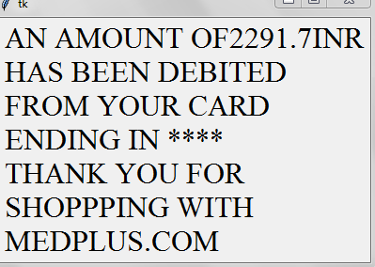**4.3.4 AFTER SUCCESSFUL PAYMENT**

**5.BILL GENERATION**

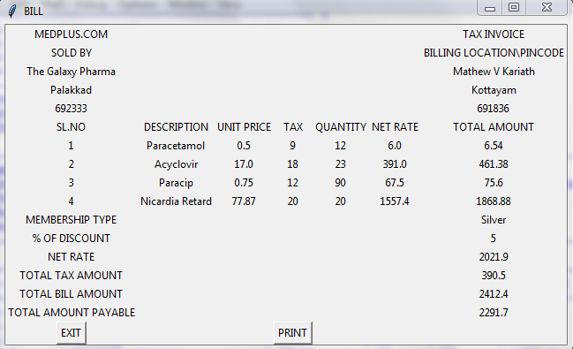

ON CLICKING “PRINT”-THE EXCEL FILE NAMED “BILL ” WILL POP UP AND THE BILL IS PRINTED IF CONNECTED TO A PRINTER

PRINT PREVIEW OF THE EXCEL SHEET

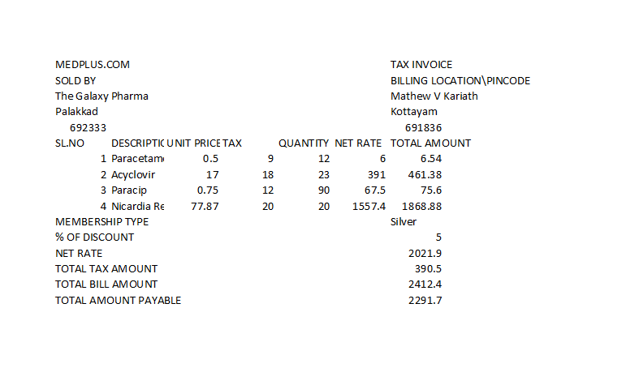

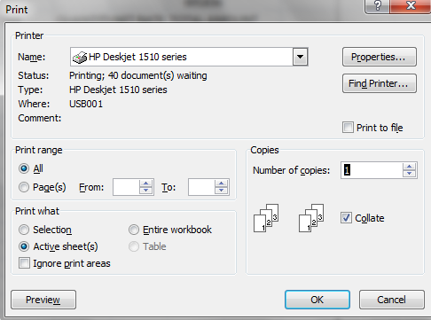

ON CLICKING “OK” THE PRINTER GETS ACTIVE AND PRINTS THE DOCUMENT

**6.CLOSING**

THANK YOU FOR CHOOSING MEDPLUS.COM



**SELLER**

**1.LOGIN AND REGISTRATION**

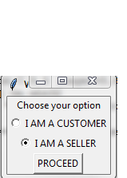

**1.1EXISTING USER-LOGIN**



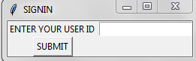

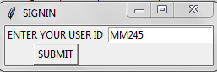

**1.1.1USERNAME NOT FOUND IN DATABASE**



**1.1.2PASS WORD AND USERNAME MATCHED**

HAI MG MEDICALS WELCOME TO MEDPLUS.COM

**1.2 NEW CUSTOMER REGISTRATION**



HAI SELLER TO VIEW YOUR REPORTS PLEASE REGISTER

PRESS THE ENTER THE ENTER KEY TO REGISTER AS A SELLER:

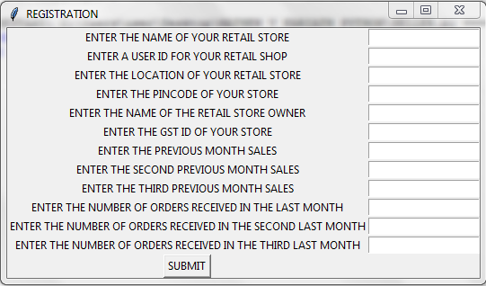

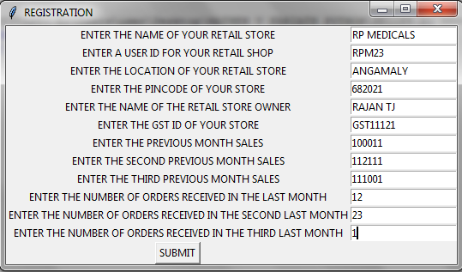

HAI RP MEDICALS WELCOME TO MEDPLUS.COM

1.VIEW MY PROFILE

2.REPORTS

**2.VIEW MY PROFILE**



YOU CAN EDIT THE DETAILS

1.EDIT DETAILS

2.EXIT

**2.1EDITING DETAILS**

NOTE:THE USER CAN NOW EDIT THE DETAILS REGARDING HIS RETAIL STORE

PLEASE ENTER YOUR CHOICE: 1

1.STORE DETAILS

2.FINANCIAL DETAILS

ENTER YOUR OPTION:

2.1.1 STORE DETAILS

NOTE:THE USER CAN EDIT DETAILS REGARDING THE STORE LIKE NAME OF RETAIL STORE,NAME OF OWNER AND LOCATION

1.NAME OF THE RETAIL STORE

2.NAME OF OWNER

3.LOCATION AND PINCODE

2.1.1.1 NAME OF RETAIL STORE

ENTER YOUR CHOICE:1

ENTER THE OLD NAME OF THE RETAILS STORE AS PER REGISTERED: MG MEDICALS

ENTER THE NEW NAME OF THE RETAILS STORE TO BE REGISTERED: MG PHARMACY

2.1.1.2 NAME OF OWNER

ENTER YOUR CHOICE:2

ENTER THE OLD NAME OF THE OWNER AS PER REGISTERED: THOMAS

ENTER THE NEW NAME OF THE OWNER STORE TO BE REGISTERED: JOSEPH

2.1.1.3 LOCATION AND PINCODE

ENTER YOUR CHOICE:3

ENTER THE OLD LOCATION STORE AS PER REGISTERED: Moonar

ENTER THE NEW LOCATION THE RETAILS STORE TO BE REGISTERED: IDUKKI

ENTER THE NEW PINCODE OF THE AREA: 682020

**2.1.2 FINANCIAL DETAILS**

NOTE:THE USER CAN CHANGE THE DETAILS LIKE HIS SALES OF THE PREVIOUS MONTH AND THE GST NUMBER

1.GST NUMBER

2.SALES

ENTER YOUR CHOICE:

**2.1.2.1 GST NUMBER**

ENTER YOUR CHOICE: 1

ENETER THE OLD GST REGISTERED: GST123123

ENETER THE NEW GST RETAILS STORE TO BE REGISTERED: GST123120

**2.1.2.2 SALES AMOUNT**

ENTER YOUR CHOICE: 2

ENETER THE NEW SALES OF THE RETAILS STORE TO BE REGISTERED11000

**2.2 DETAILS AFTER EDIT**



**3.REPORTS SECTION**

WELCOME TO THE REPORT SECTION OF ALL REGISTERD SELLERS

1.VIEW ALL SELLERS

2.VIEW MY NEIGHBOURS

3.VIEW MY COMPETITIONS

4.SEE RANKING AND VIEW MY RANK

5.VIEW PERSONAL PROFILE

6.VIEW PROJECTED SALES FOR THE NEXT MONTH

7.VIEW MARKET PULSE

ENTER YOUR CHOICE:

**3.1 VIEW ALL SELLERS**

NOTE:VIEW THE BAR GRAPH OF ALL SELLERS REGISTERED WITH MEDPLUS.COM

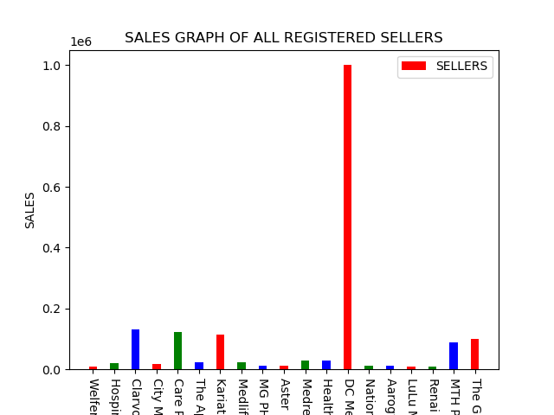

**3.2 VIEW NEIGHBOURS**

NOTE:THE SELLER CAN VIEW ALL HIS NIGHBOURS AS WELL AS THEIR SALES

1.VIEW ALL MY NEIGHBOURS

2.GRAPHICALLY VIEW MY NEIGHBOURS

ENTER YOUR CHOICE:

**3.2.1 VIEW ALL MY NEIGHBOURS**

ENTER YOUR CHOICE: 1

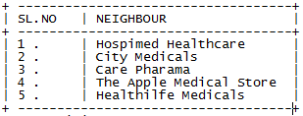

**3.2.2 GRAPHICALLY VIEW MY NEIGHBOURS**

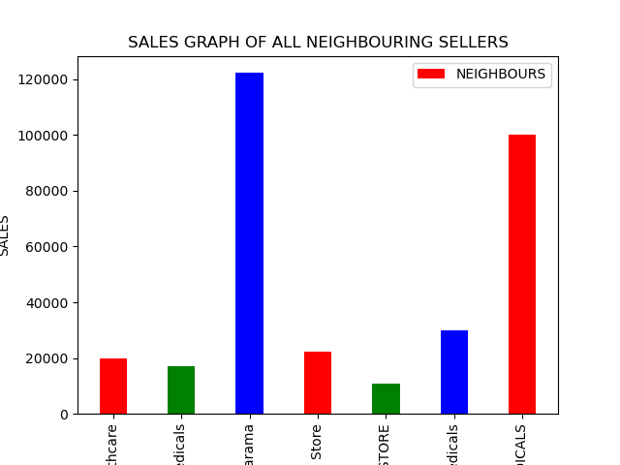

**3.3 VIEW COMPETITORS**

NOTE:THE SELLER CAN VIEW ALL HIS COMPETITINS AS WELL AS THEIR SALES

1.SET LIMIT

2.PROCEED WITH DEFAULT LIMIT

ENTER YOUR CHOICE:

**3.3.1 SETTING A LIMIT OF COMPARISON**

NOTE:NOW THE USER CAN SET A LIMIT IN RUPEES TO COMPARE HIMSELF

WITH OTHERS

ENTER YOUR CHOICE: 1

ENTER YOUR LIMIT: 100000

1.VIEW ALL MY COMPETITIONS

2.GRAPHICALLY VIEW MY COMPETITIONS

ENTER YOUR CHOICE:

**3.3.1.1 VIEW ALL COMPETITIONS**

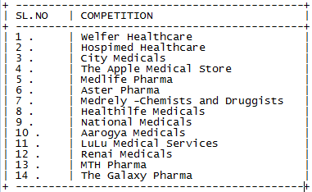

**3.3.1.2 GRAPHICALLY VIEW MY COMPETITIONS**

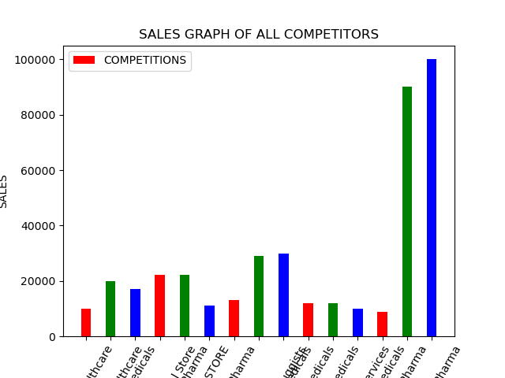

**3.3.2 PROCEEDING WITH THE DEFAULT VALUE**

**3.3.2.1 VIEW ALL COMPETITIONS**

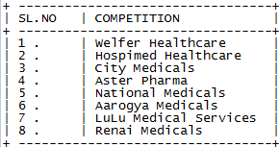

**3.3.2.2 GRAPHICALLY VIEW MY COMPETITIONS**

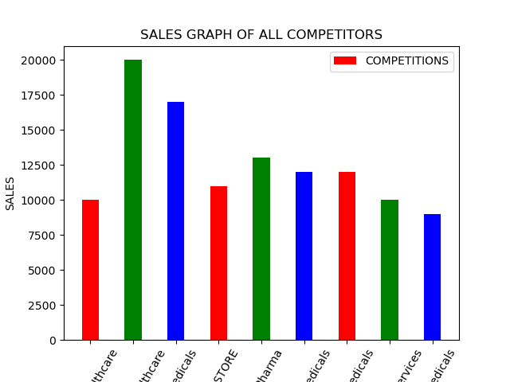

**3.4 VIEW RANKING AND THE SELLER’S POSITION**

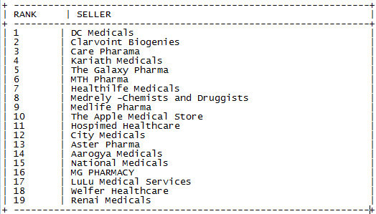

CONGRATS YOU ARE IN THE 16 th position

**3.5 VIEW PERSONAL PROFILE**

1.SEE MY GROWTH

2.SEE MY MONTHLY SALES DISTRIBUTION

ENTER YOUR CHOICE:

**3.5.1 VIEW THE SELLER’S GROWTH**

NOTE: THE USER CAN NOW VIEW THE LINE GRAPH WITH ORDERS AND SALES

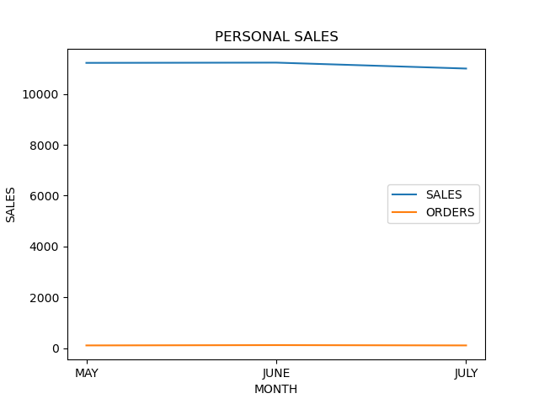

**3.5.2 VIEW MONTHLY SALES DISTRIBUTION FOR THW LAST 3 MONTHS**

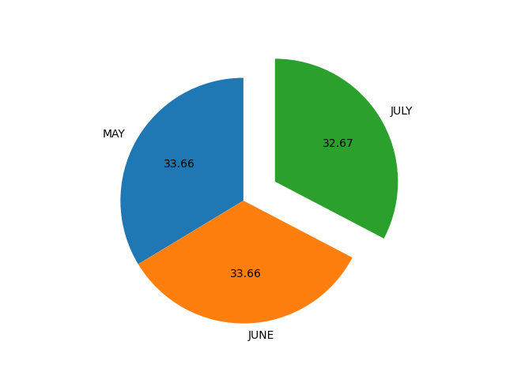 NOTE: THE USER CAN NOW VIEW THE PIE PLOT OF THE LAST 3 MONTH’S SALES

**3.6 VIEW PROJECTED SALES FOR THE NEXT MONTH**

DEAR MG PHARMACY YOUR PROJECTED SALES FOR THE NEXT MONTH IS 11223

**3.7 VIEW MARKET PULSE**

NOTE:GIVES A GENERAL IDEA ABOUT THE SALES AND ORDERS IN THE MARKET FOR THE PAST 3 MONTHS

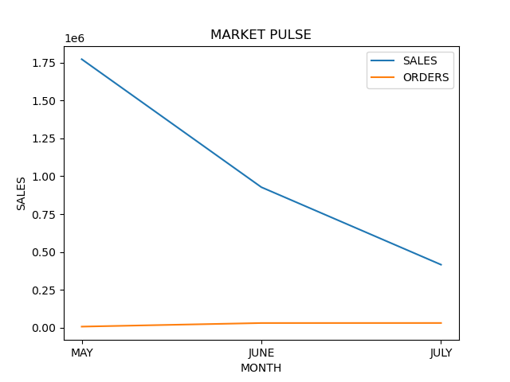

**4.CLOSING**

DISPLAY ALL THE GRAPH GENERATED IN A SINGLE WINDOW

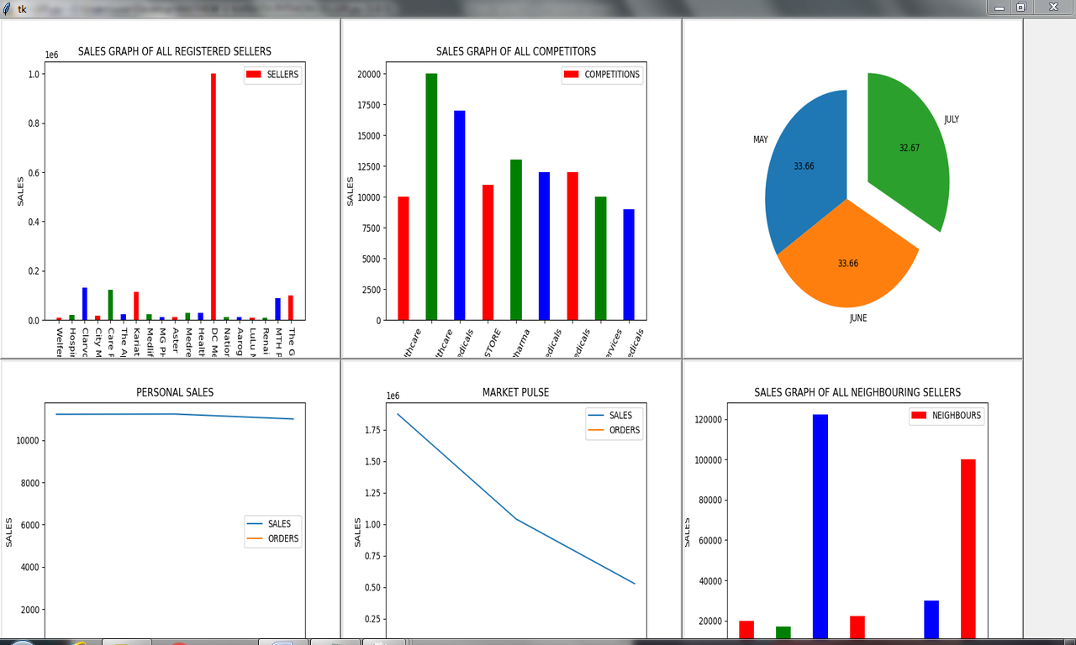

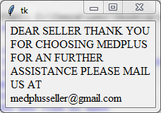

**5.TERMS AND CONDITIONS**

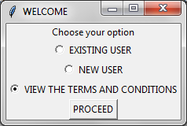

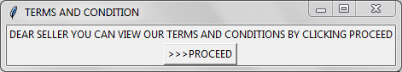

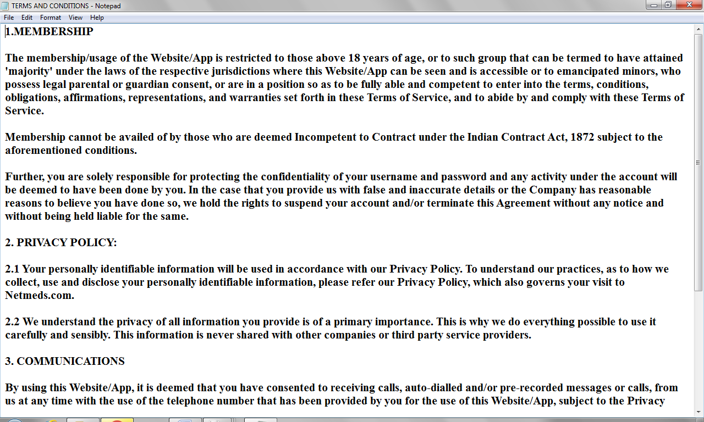

THANK YOU FOR SHOPPING WITH MEDPLUS